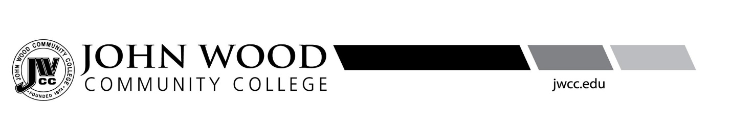

Notice of Public Hearing Concerning the Intent of
the Board of Trustees of
Community College District No. 539,
Counties of Adams, Pike, Hancock, Calhoun, Schuyler, Brown, Morgan, Scott and Cass and State of Illinois
to Sell $5,100,000 Funding Bonds
Public Notice is Hereby Given that Community College District No. 539, Counties of Adams, Pike, Hancock, Calhoun, Schuyler, Brown, Morgan, Scott and Cass and State of Illinois (the “District”), will hold a public hearing on the 20th day of October, 2021, at 6:00 o’clock P.M. The hearing will be held at the John Wood Community College, 1301 South 48th Street, Quincy, Illinois. The purpose of the hearing will be to receive public comments on the proposal to sell bonds of the District in the amount of $5,100,000 for the purpose of paying claims against the District.
By order of the Chair of the Board of Trustees of Community College District No. 539, Counties of Adams, Pike, Hancock, Calhoun, Schuyler, Brown, Morgan, Scott and Cass and State of Illinois.
Dated the 12th day of October, 2021.

Andy Sprague
Secretary, Board of Trustees,
Community College District No. 539, Counties of Adams, Pike, Hancock, Calhoun, Schuyler, Brown, Morgan, Scott and Cass and State of Illinois

