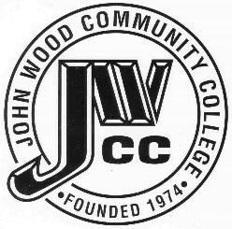 | Finance & Audit Committee Agenda  Meeting Date: 10.12.21  Meeting Time: 3:30 p.m.  Meeting Location: Zoom

AGENDA ITEMS:

- Review Bills for Payment

- Review Financials

- Review Board Budget

- Review President’s Expense Account

- Review & Discuss Investments

- Board Items

  - Tax Levy
  - Abatement
  - CBA
  - PHS Projects
  - Erosion Repairs & Storm Drain Installation RFP’s
  - Resolution-Intent to Issue Funding Bonds

- Other

