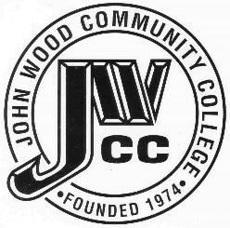 | Finance & Audit Committee Agenda  Meeting Date: 12.09.21  Meeting Time: 3:00 p.m.  Meeting Location: Zoom

AGENDA ITEMS:

- Review Bond Proposals

- Other

