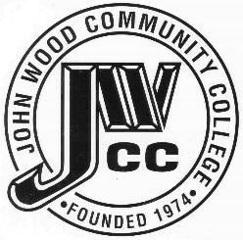 | Finance & Audit Committee Agenda  Meeting Date: 10.13 22  Meeting Time: 8:00 a.m.  Meeting Location: C240

AGENDA ITEMS:

- Review Bills for Payment

- Review Travel Requests

- Review Financials

- Review Board Budget

- Review President’s Expense Account

- Review & Discuss Investments

- Board Items

  - Tax Levy
  - Abatement
  - PHS Projects
  - Insurance Premiums

- Other

