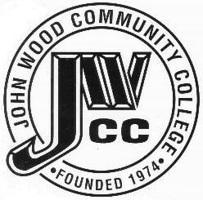 | Finance & Audit Committee Agenda  Meeting Date: 04.17 23  Meeting Time: 2:00 a.m.  Meeting Location: C240

AGENDA ITEMS:

- Review Bills for Payment

- Review Travel Requests

- Review Financials

- Review Board Budget

- Review & Discuss Investments

- Board Items

  - Parking Lot Concrete Improvements RFP

- Other

