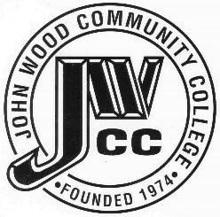 | Finance & Audit Committee Agenda  Meeting Date: 07.17 23  Meeting Time: 2:00 p.m.  Meeting Location: C240

AGENDA ITEMS:

- Review Bills for Payment

- Review Travel Requests

- Review & Discuss Investments

- Board Items

  - Approved Budget
  - RAMP

- Other

