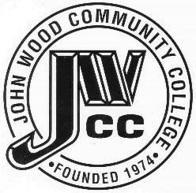 | Finance & Audit Committee Agenda  Meeting Date: 09.13 23  Meeting Time: 2:00 p.m.  Meeting Location: C240

AGENDA ITEMS:

- Review Bills for Payment

- Review Travel Requests

- Review & Discuss Investments

- Board Items

  - Instructor Stations RFP
  - Cyclorama Lighting RFP
  - Ag Driving Simulator with Motion Base RFP
  - WDC Expansion Furniture RFP
  - Transfer
  - MOU-Quincy Children’s Museum Storywalk
  - MOU-West Central Illinois Criminal Justice Council

- Other

