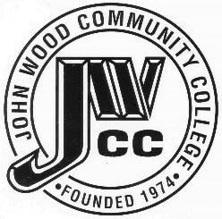 | Finance & Audit Committee Agenda  Meeting Date: 10.16 23  Meeting Time: 2:00 p.m.  Meeting Location: C240

AGENDA ITEMS:

- Review Bills for Payment

- Review Travel Requests

- Review Financials

- Review Board Budget

- Review & Discuss Investments

- Board Items

  - Tax Levy
  - Abatement
  - Insurance Premiums
  - WDC Expansion Furniture RFP’s
  - MOU-Tuition Reimbursement

- Other

