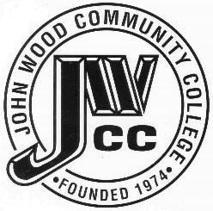 | Finance & Audit Committee Agenda  Meeting Date: 11.08 23  Meeting Time: 2:00 p.m.  Meeting Location: C240

AGENDA ITEMS:

- Review Bills for Payment

- Review Travel Requests

- Review Financials

- Review Board Budget

- Review & Discuss Investments

- Board Items

  - Tax Levy
  - Audit
  - PHS Projects
  - Piping Trainer Bid
  - Hydraulics Trainer Bid
  - Pneumatic Trainer Bid
  - Single Pump System Trainer Bid
  - Copier RFP
  - Mt. Sterling Lease-Two Rivers Regional

- Other

