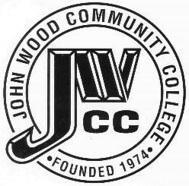 | Finance & Audit Committee Agenda  Meeting Date: 12.11 23  Meeting Time: 2:00 p.m.  Meeting Location: President’s Conference Room

AGENDA ITEMS:

- Review Bills for Payment

- Review Travel Requests

- Review Financials

- Review Board Budget

- Review & Discuss Investments

- Board Items

  - Tax Levy – Levying Additional Tax
  - Tax Levy – Levying Taxes
  - BP 414 Change
  - Parking Lot Lighting Bids

- Other

