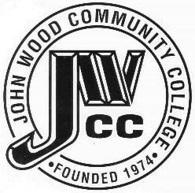 | Finance & Audit Committee Agenda  Meeting Date: 04.10 24  Meeting Time: 2:00 p.m.  Meeting Location: C240

AGENDA ITEMS:

- Review Bills for Payment

- Review Travel Requests

- Review Financials

- Review Board Budget

- Review & Discuss Investments

- Board Items

  - Tuition
  - Upward Bound Travel Request for Proposals

- Other

