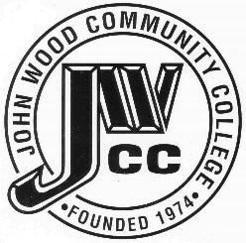 | Finance & Audit Committee Agenda  Meeting Date: 05.14 25  Meeting Time: 3:30 p.m.  Meeting Location: C240

AGENDA ITEMS:

- RSVP Presentation

- Review Bills for Payment

- Review Travel Requests

- Review Financials

- Review Board Budget

- Review & Discuss Investments

- Board Items

- Trust Agreement for CDB Project
- Memorandum of Understanding with Quincy Rush Soccer Club
- Replacement of Boilers for Science & Technology Center

- Other

